The Golden Ratio

The Golden Ratio is a mathematical concept that has been used to make designs aesthetically pleasing. Having been used for over 2000 years, the golden ratio has been used in nature, science, art and architecture. The golden ratio can also be applied to website design. This ratio is based on a mathematical equation which produces a ratio that is equal to 1.618.

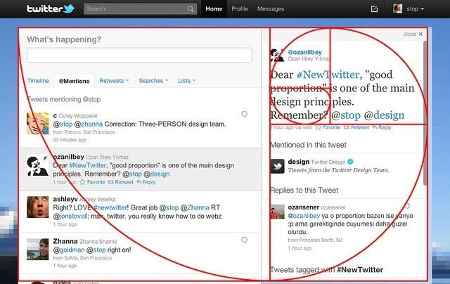

The image above shows how to golden ratio works on a social media website. It shows where someone’s eye supposedly looks on that particular page. This also shows that the theory that the bottom right corner of a website is often skipped, as the red line shows that the eye starts at the top left corner, skips through the bottom right corner and focuses on the top right corner.